Midterm Lab Exam
Baklaga Luka

Task 1 – AES Encryption
Github – Midterm/Task1 at main · lukabaklaga123/Midterm

Task 1A: Encrypt a file using AES-128-CBC
- I have created secret.txt file with the following command:

Set-Content -Path secret.txt -Value "This file contains top secret docs."
Output:

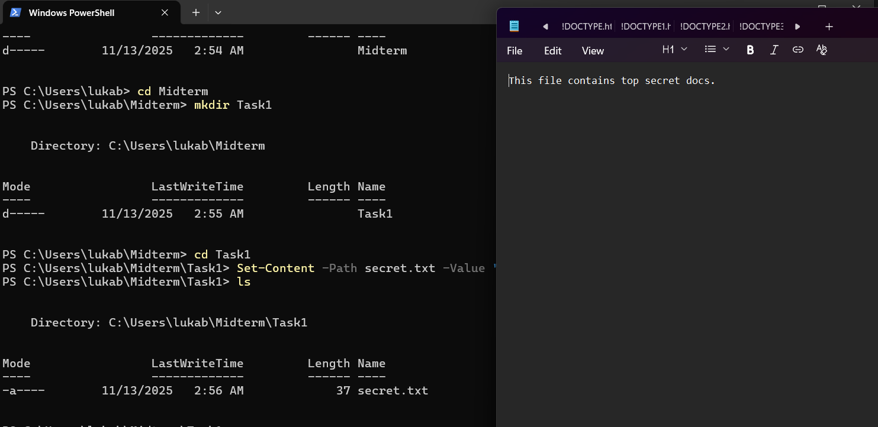

- Encrypt with AES-128-CBC using a passphrase:

For the passphrase I used “MySecretPass123” which is OpenSSL Standard.
I am using following command:
openssl enc -aes-128-cbc -e -in secret.txt -out secret.enc -pass pass:MySecretPass123

Output:
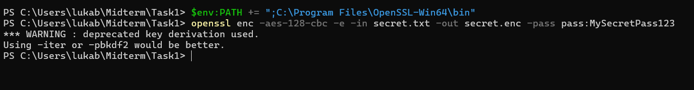

Task 1B: Decrypt secret.enc

I need to decrypt the file using the same passphrase:
openssl enc -aes-128-cbc -d -in secret.enc -out secret_decrypted.txt -pass pass:MySecretPass123

cat secret_decrypted.txt

Output:
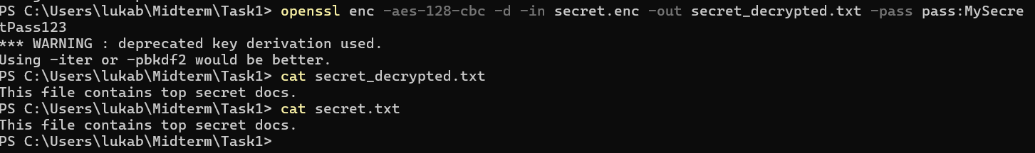

Task 2 - ECC Signature Verification
Github: Midterm/Task2 at main · lukabaklaga123/Midterm

Task 2A: Generate ECC keys
- I am going to generate ECC private key (using the prime256v1 curve):
openssl ecparam -name prime256v1 -genkey -out ecc_private.pem

- Now I am going to extract the public key from the private key:
openssl ec -in ecc_private.pem -pubout -out ecc_public.pem

There is no visible outputs.

Task 2B: Sign and verify a message

- Now I am going to create ecc.txt file:
Set-Content -Path ecc.txt -Value "Elliptic Curves are efficient."
- And sign the file's hash with the private key:
openssl dgst -sha256 -sign ecc_private.pem -out ecc.sig ecc.txt

I am using openssl dgst to first hash the file with SHA-256 and then sign that hash using my ECC private key.

- Now I need to verify the signature using the public key:
openssl dgst -sha256 -verify ecc_public.pem -signature ecc.sig ecc.txt

Output:
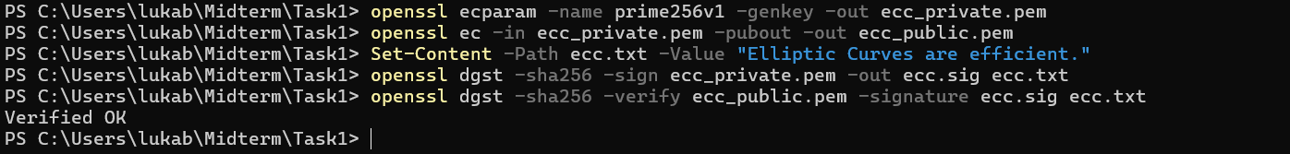

Task 3 - Hashing & HMAC
Github: Midterm/Task3 at main · lukabaklaga123/Midterm
Task 3A: SHA-256 Hash

- Firstly, let’s create data.txt file:

Set-Content -Path data.txt -Value "Never trust, always verify."

- Then, hash the file using SHA-256:
openssl dgst -sha256 data.txt

Output:
SHA2-256(data.txt)= 35dbda80a6da07e03e7d130a5c2faca79af537c449facf45748c61388d2544b9
Task 3B: HMAC using SHA-256

- We are going to create an HMAC for data.txt using the key secretkey123:
openssl dgst -sha256 -hmac "secretkey123" data.txt
HMAC-SHA2-256(data.txt)= 52e8ffc4c7b52e7a8c64914799690f3a05ce1517d9e7ffa3eb69c1fbff040ccd
Task 3C: Integrity Check

- We are going to change one letter in data.txt (N -> n):
Set-Content -Path data.txt -Value "never trust, always verify."

- And recompute the HMAC with the same key:
openssl dgst -sha256 -hmac "secretkey123" data.txt

Output:
HMAC-SHA2-256(data.txt)= f116e2fafab773276ae1edf961d89344a70a2d1f82f0f7065ed65f6ed79f4679

Changing a single character in the input file (from 'N' to 'n') caused the final HMAC output to change completely. This demonstrates the avalanche effect inherent in hash functions.
This is why HMAC is important:
- Integrity: If a receiver calculates the HMAC on the file they received and it does not match the HMAC sent by the sender, they immediately know that the file has been tampered with, even by a single bit.
- Authenticity: An attacker cannot create a valid new HMAC for a tampered file because they do not possess the secret key.
HMAC provides both integrity (ensuring the data is unchanged) and authenticity (verifying the data originated from someone who knows the secret key).

Task 4 - Diffie-Hellman Key Exchange
Github

Task 4A: Simulate DH Key Exchange
Github- Midterm/Task4 at main · lukabaklaga123/Midterm
- Now we are going to generate shared DH parameters (prime p and generator g):
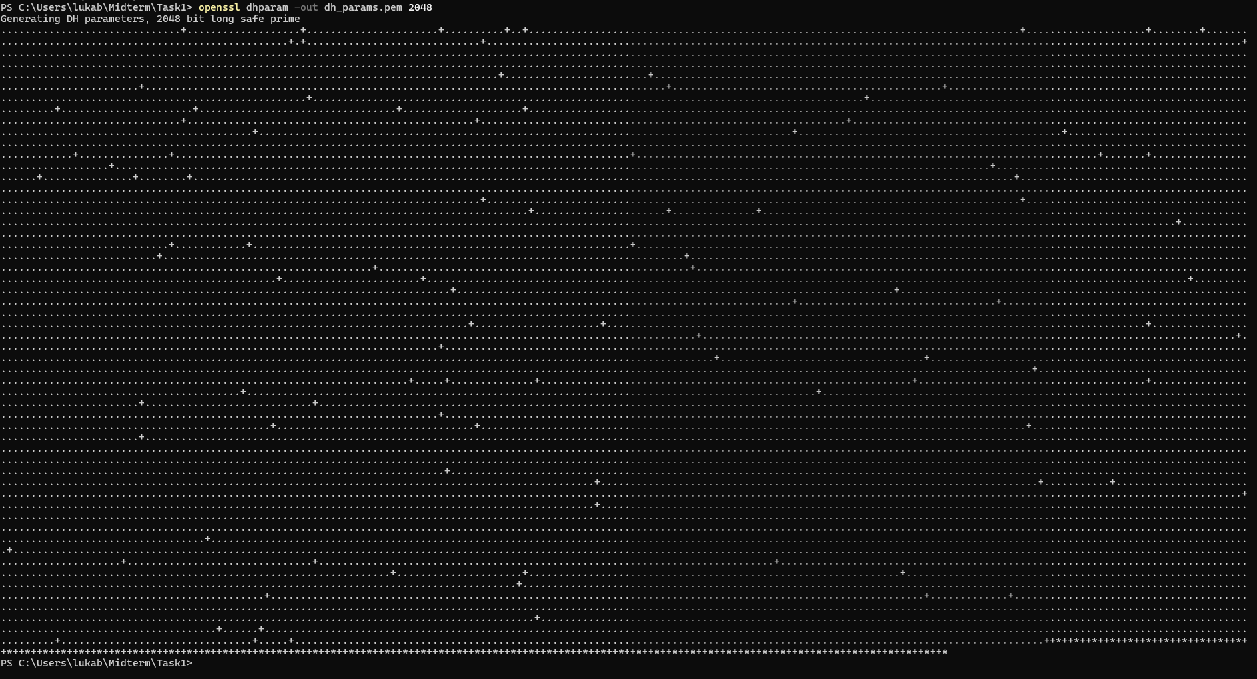

- Alice generates her private and public keys:
openssl genpkey -paramfile dh_params.pem -out alice_private.pem
openssl pkey -in alice_private.pem -pubout -out alice_public.pem

Output:


- Bob generates his private and public keys: He uses the same parameter file.
openssl genpkey -paramfile dh_params.pem -out bob_private.pem
openssl pkey -in bob_private.pem -pubout -out bob_public.pem

Output:

- Now Alice and Bob derive the shared secret:
openssl pkeyutl -derive -inkey alice_private.pem -peerkey bob_public.pem -out alice_secret.bin
openssl pkeyutl -derive -inkey bob_private.pem -peerkey alice_public.pem -out bob_secret.bin
- Alice uses her private key and Bob's public key.
- Bob uses his private key and Alice's public key.
Output:

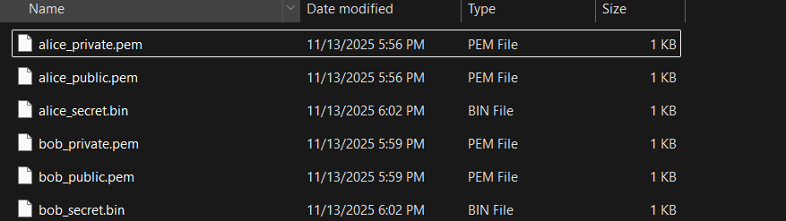

- We can now show that both shared keys are identical:
openssl dgst -sha256 alice_secret.bin bob_secret.bin

Output:

SHA2-256(alice_secret.bin)= 47a15a482bb69dfa4c34df7e2a5e1f5b443a932fafd434a0d9ed8716d1fe8fc1
SHA2-256(bob_secret.bin)= 47a15a482bb69dfa4c34df7e2a5e1f5b443a932fafd434a0d9ed8716d1fe8fc1

Task 4B: Real-Life Application

Diffie-Hellman (DH) is a foundational protocol in modern cryptography. Its primary purpose is to establish a secure shared secret for symmetric encryption over an insecure public channel, such as the internet, where eavesdroppers may be present.Its most common application is in the TLS handshake, which secures HTTPS web traffic. When your browser connects to a secure website, it uses an ephemeral version of Diffie-Hellman (DHE) or Elliptic Curve Diffie-Hellman (ECDH) to negotiate a one-time-use symmetric session key (such as an AES key). This key is then used to encrypt all the data you send and receive during that session.

It is also a core component of secure messaging apps such as Signal. The Signal Protocol uses Elliptic Curve Diffie-Hellman (ECDH) to establish a secure, end-to-end encrypted channel between two users.Diffie-Hellman is important because it provides forward secrecy. Since the derived shared secret is temporary (ephemeral) and never transmitted, an attacker who steals a server's long-term private key cannot decrypt past conversations they may have recorded. This ensures that past communications remain secure even if a future key is compromised.

